1. 
2. Before talking about hash, let’s talk about JSON.
   1. Data Format for data exchange among browsers, servers, Data bases.
   2. 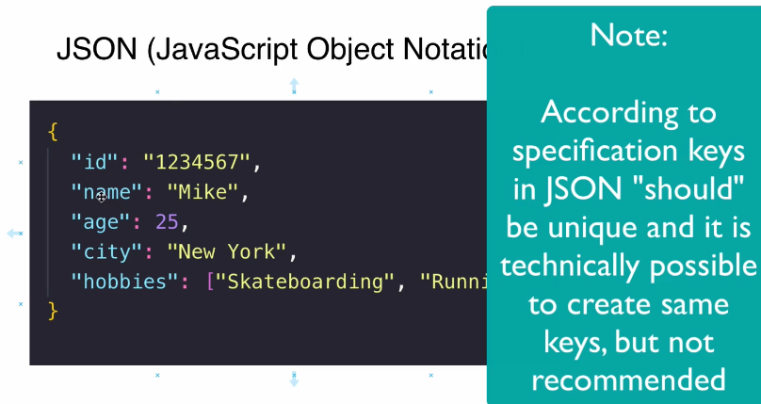
   3. Values in JSON can be repeated.
   4. The structure of git database is very similar to JSON.  
      Key in git db is the hash of the file.  
      Key: Hash code of the file.  
      Value: The file itself.
   5. 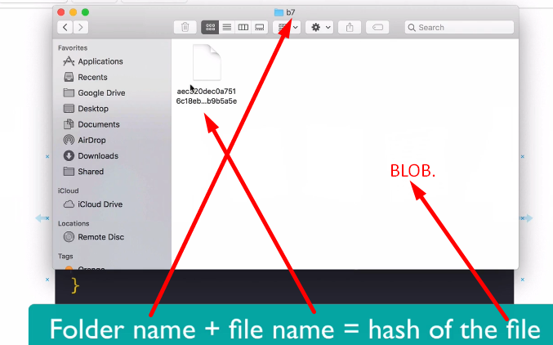
   6. In git, even value can’t be same as hashcode which is key in git is calculated based on value where value is file’s content.  
      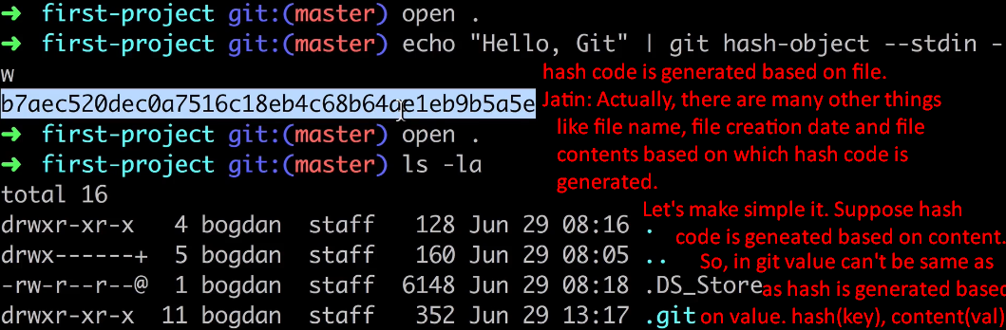
3. 